THE SWEET POP

Capstone Project

Hello everyone!

My name is DivyaSri Emandi, let’s go and see the webpage which I developed using HTML, CSS, NODE.JS, SQL QUERIES for data storage using AXIOS, API’S, GET data, POST data, SEQUILIZE, .ENV (to store key’s), NODEMODULES, PGSTORE.

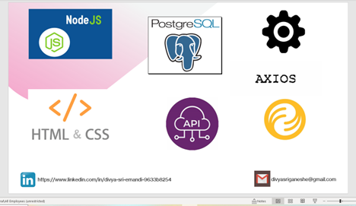

Where you can order online and pick up at store

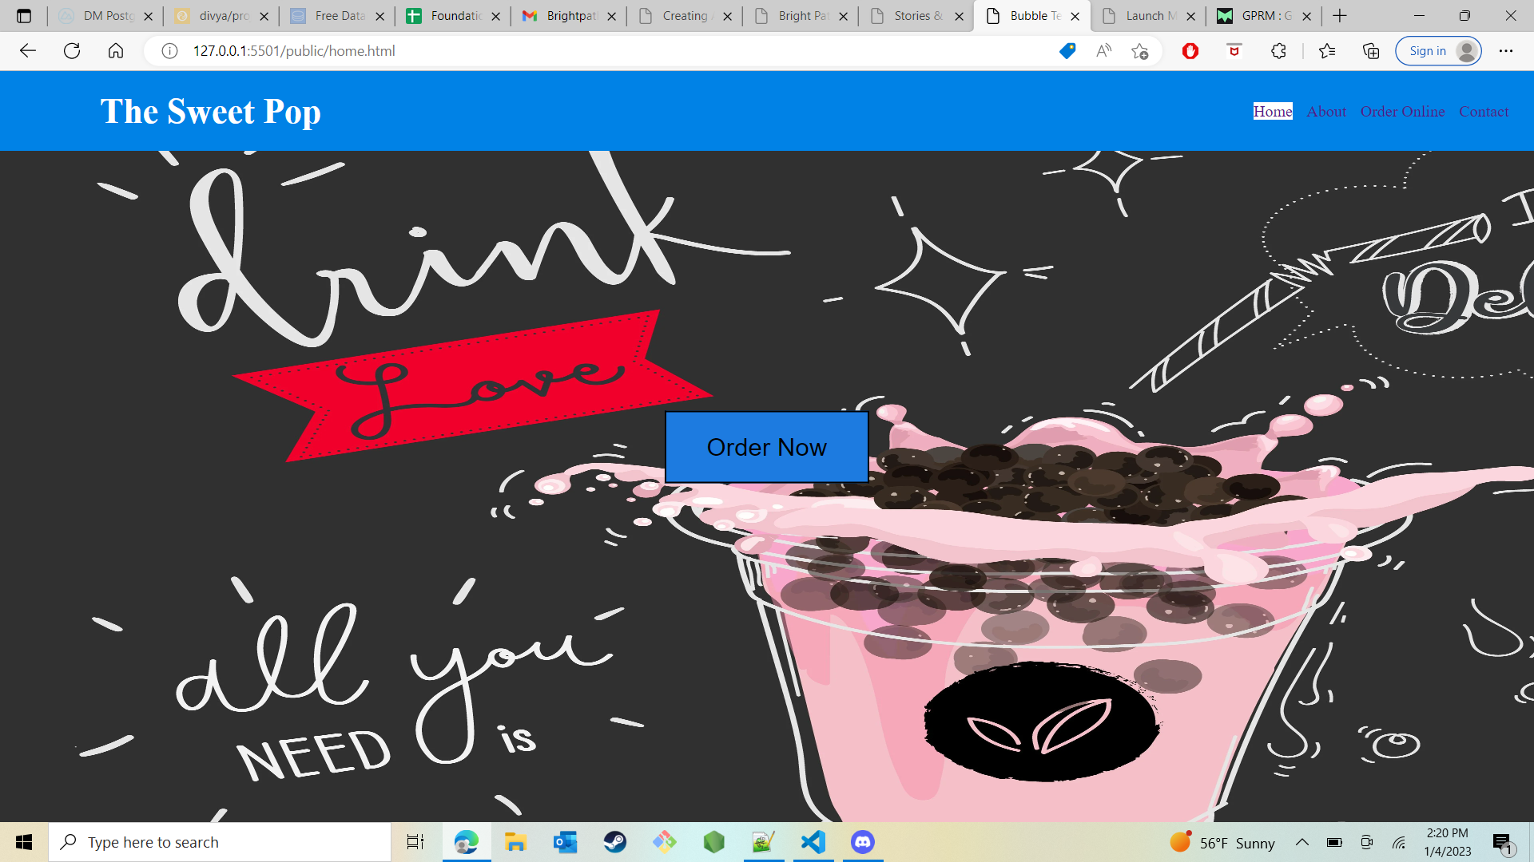

The menu contains different teas that can be selected and you can select a base that go with, you can also select the sweetness levels, and you can select level of ice you need. It will then display the order total along with tax amounts. Once this is done, the next step is to enter customer information and then the payment information,

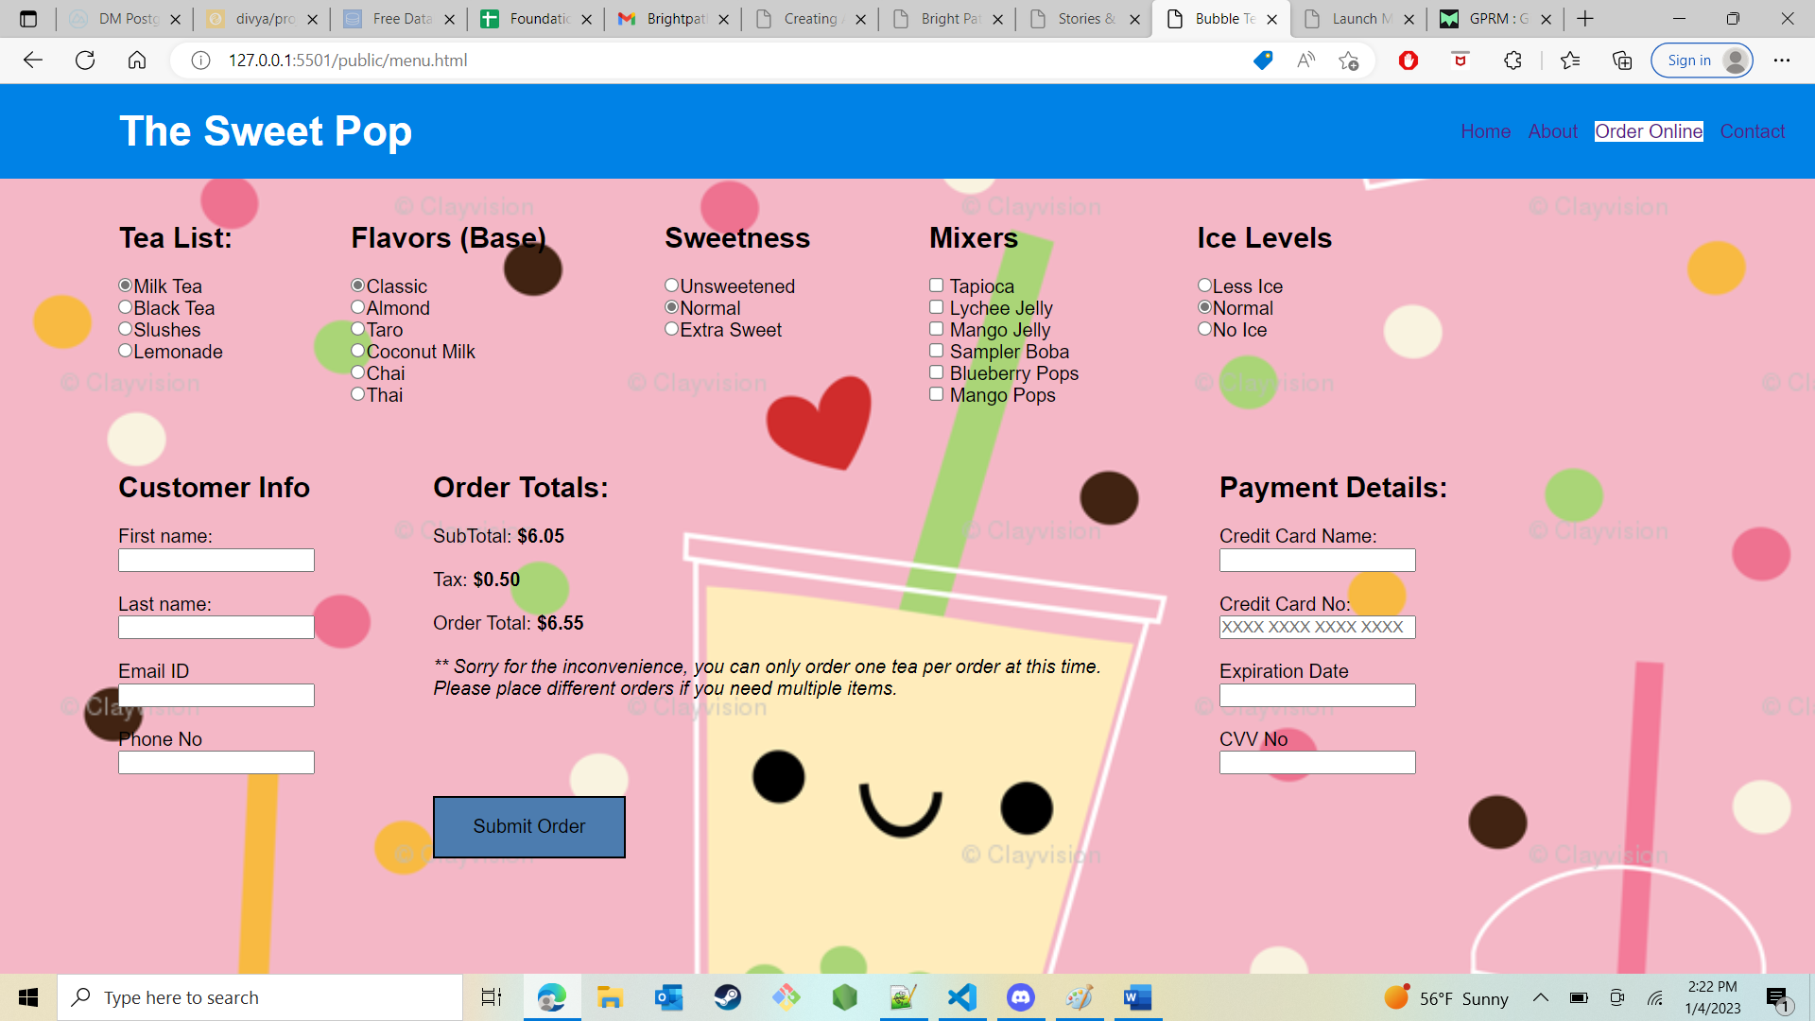

I have added a NULL check so that the website will prompt the customer to enter those fields.

Pop up message: this similar validation for every fields.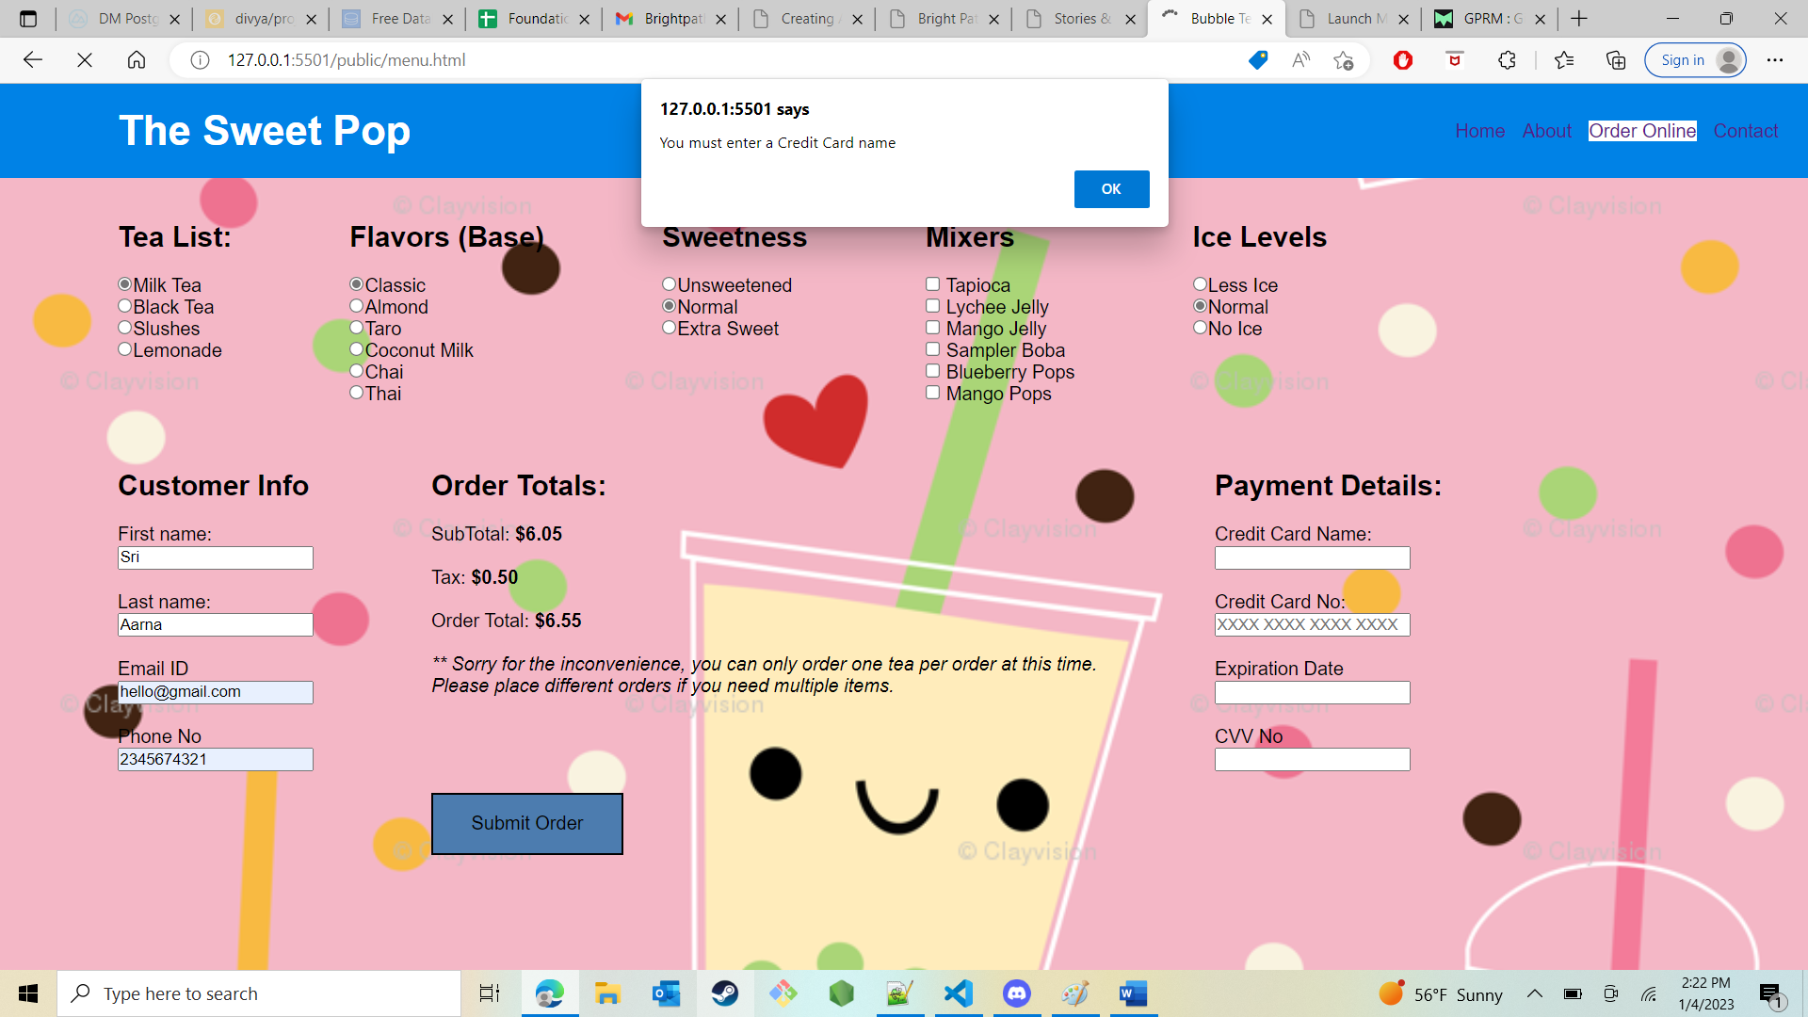

On click of submit button, I made a post call to store all the information on this page in this database tables.

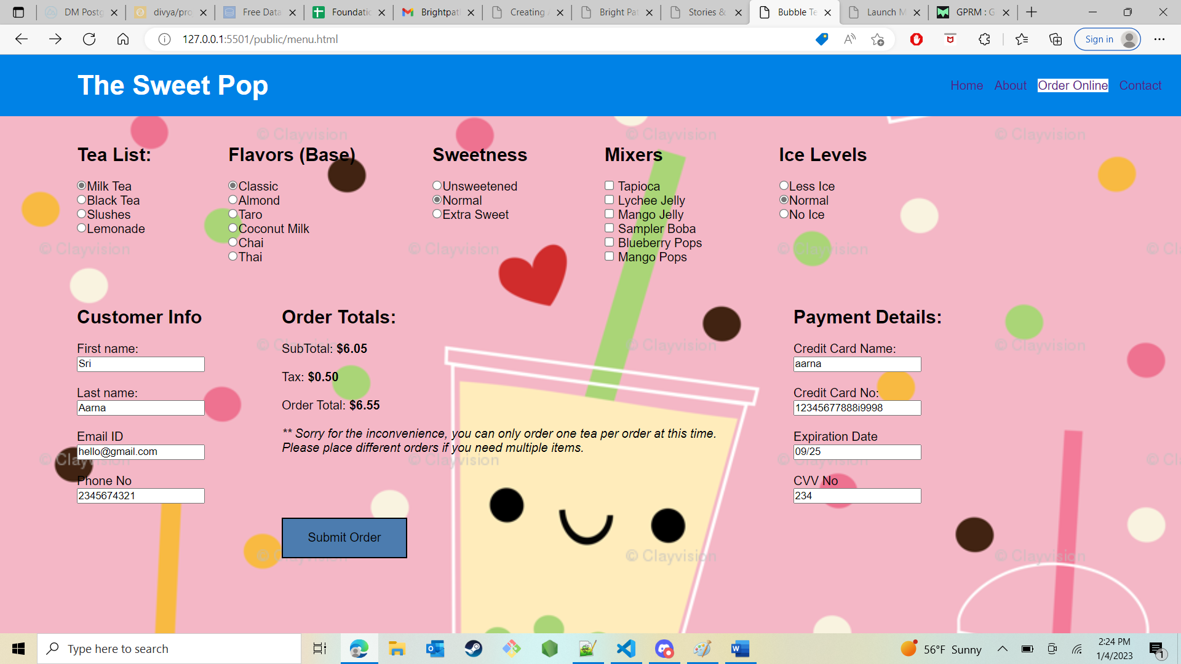

In this page, I made a get call to fetch the order number generator from the database and display it here.

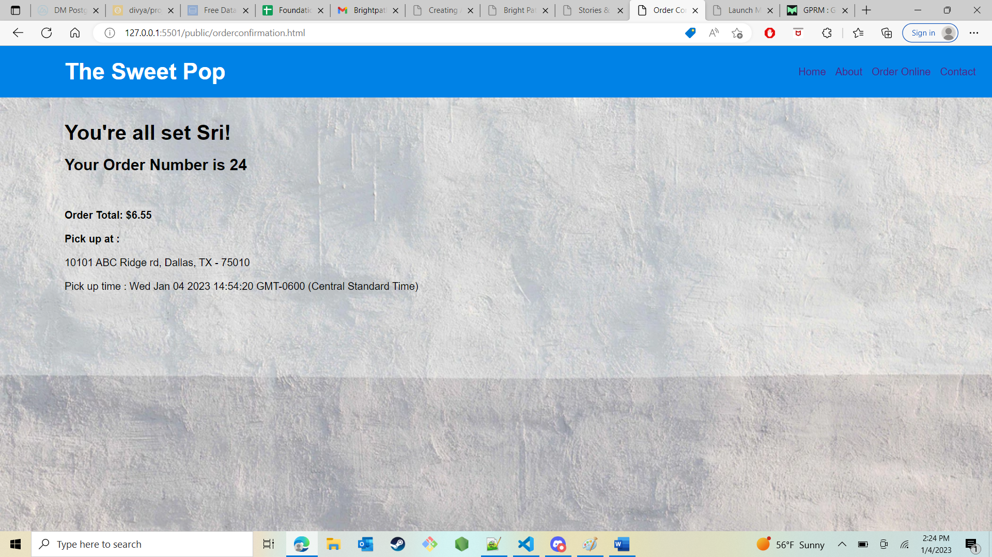

I also have the about page where it says about the sweet pop

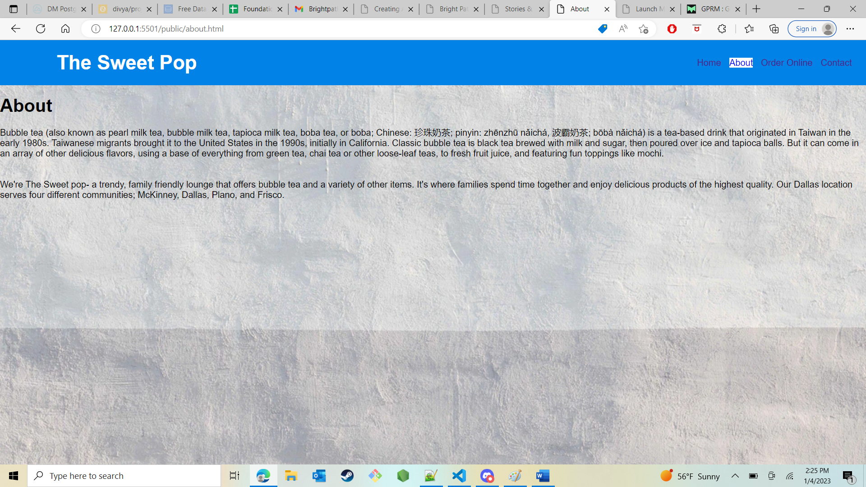

And also have the contact page where it says the contact details about the sweet pop.

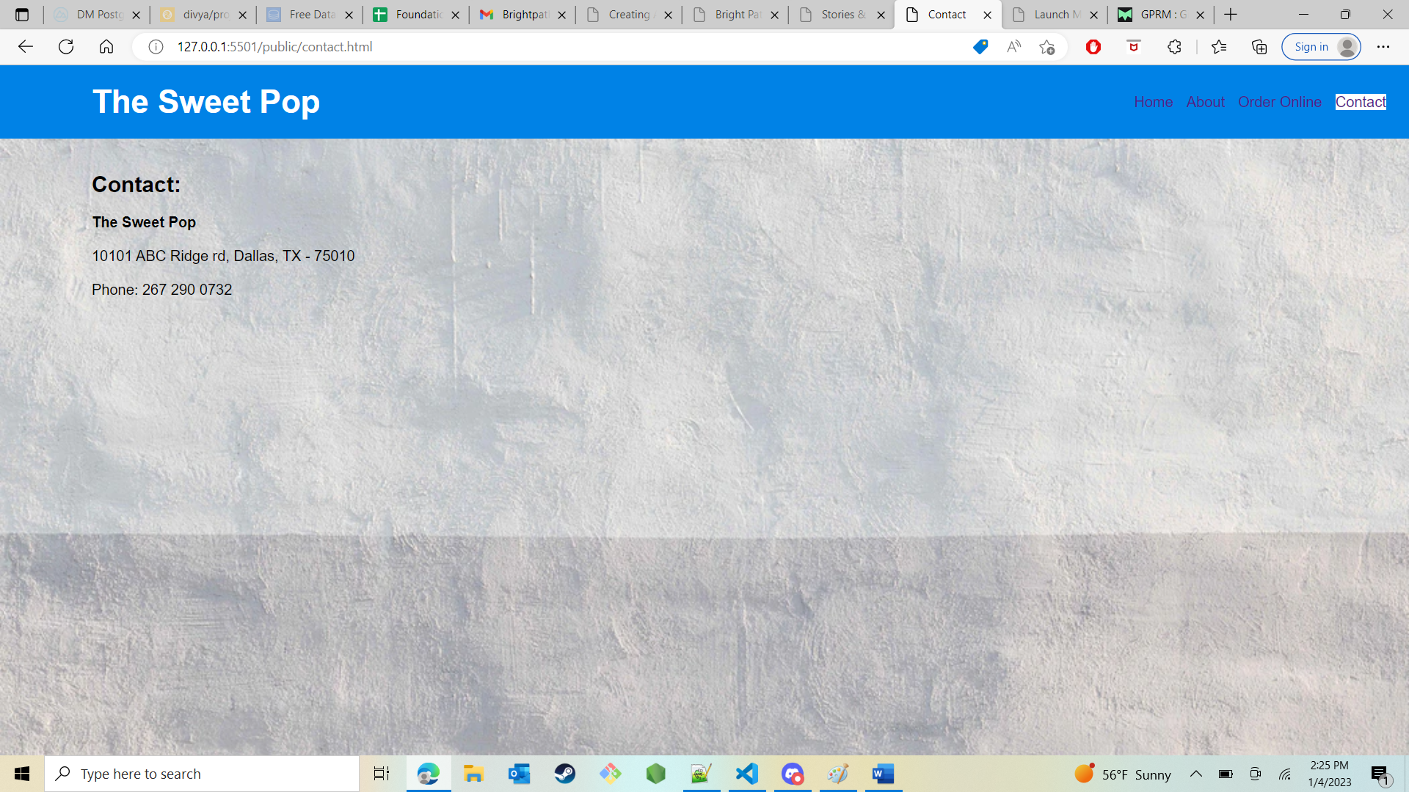

I have created a database in BIT.IO site where you can see a database table with all the necessary columns, you can also see the data for different orders that were placed.

